Gates Conversions
Note before starting:
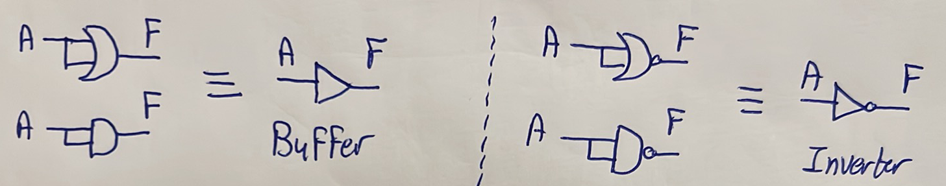
Steps in general:
- Write the expression of the gate you wish to make.
- Try to play with the expression (e.g. use De Morgan’s theorem) to write it in terms of the gate available as well as inverters.
- Kol ma yezhar m3ak inverter aw the available gate fel expression 5odo w sameh ka variable gedeed.

Using NAND Gates

NAND to AND
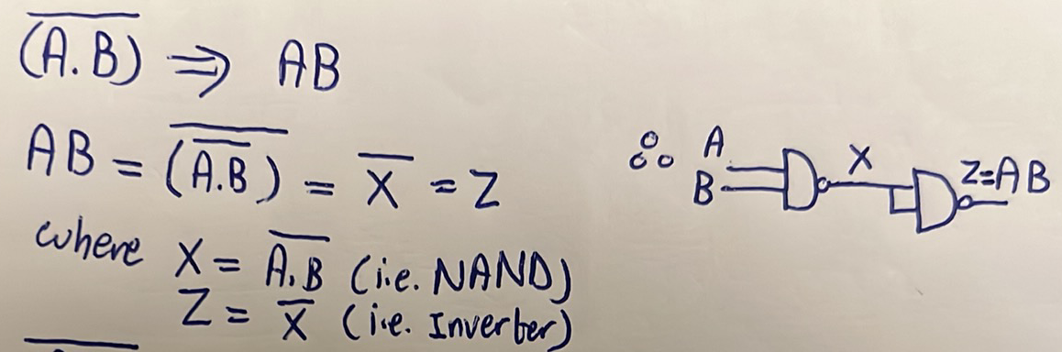
- Katabna el expression of the gate we wish to make $\left(AB\right).$
- A3adna n5abat fel expression 3ashan yezharlena el available gate (NAND) w inverters.
- Kol ma kan yezhar el available gate (NAND) aw inverter bena5odhom ka variable gedeed (X,Z).

NAND to OR
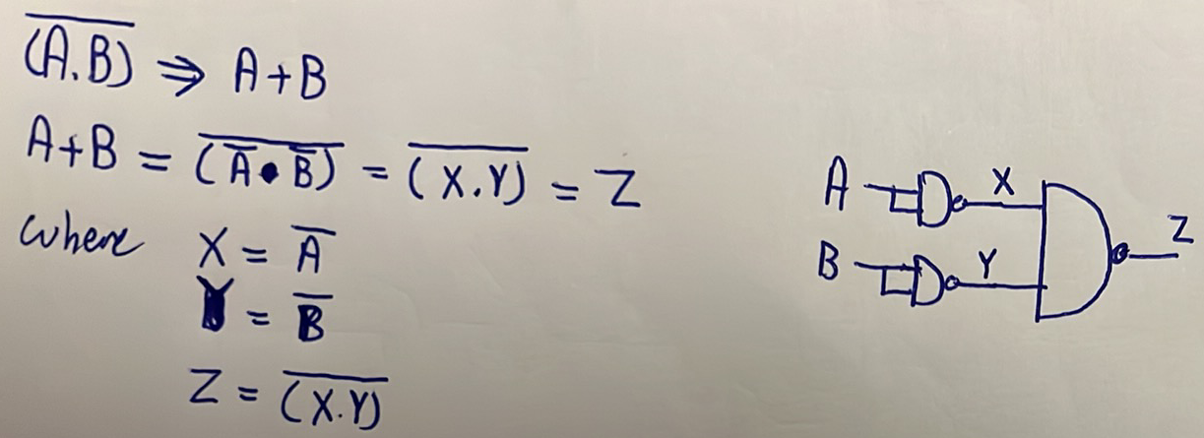

NAND to NOR
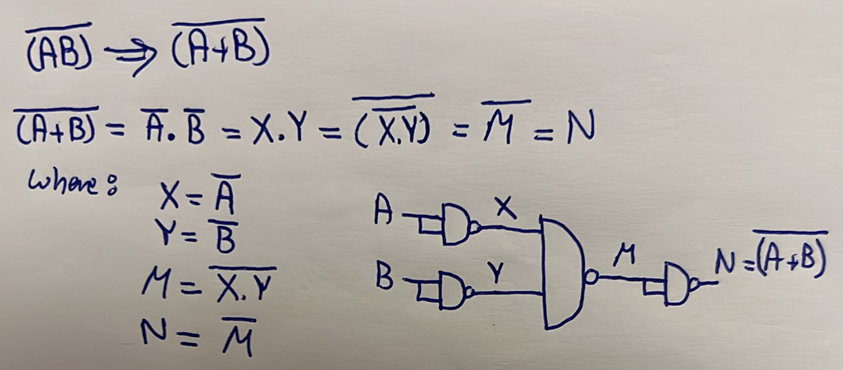

NAND to XOR
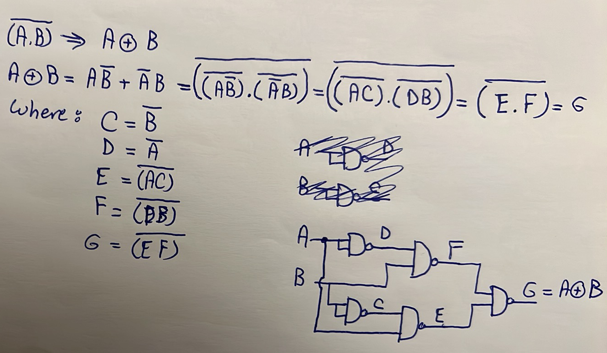
Another better solution (special for XOR gate, mesh sahl yegy 3la balak):
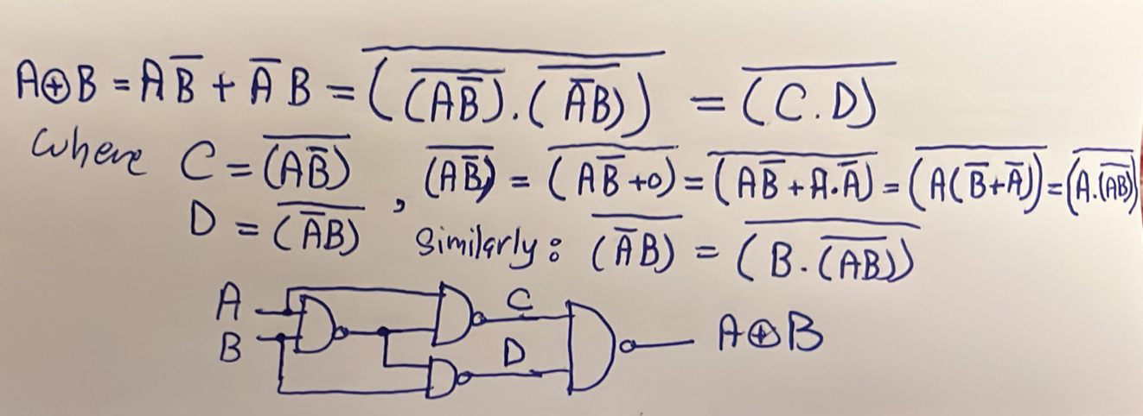

NAND to XNOR
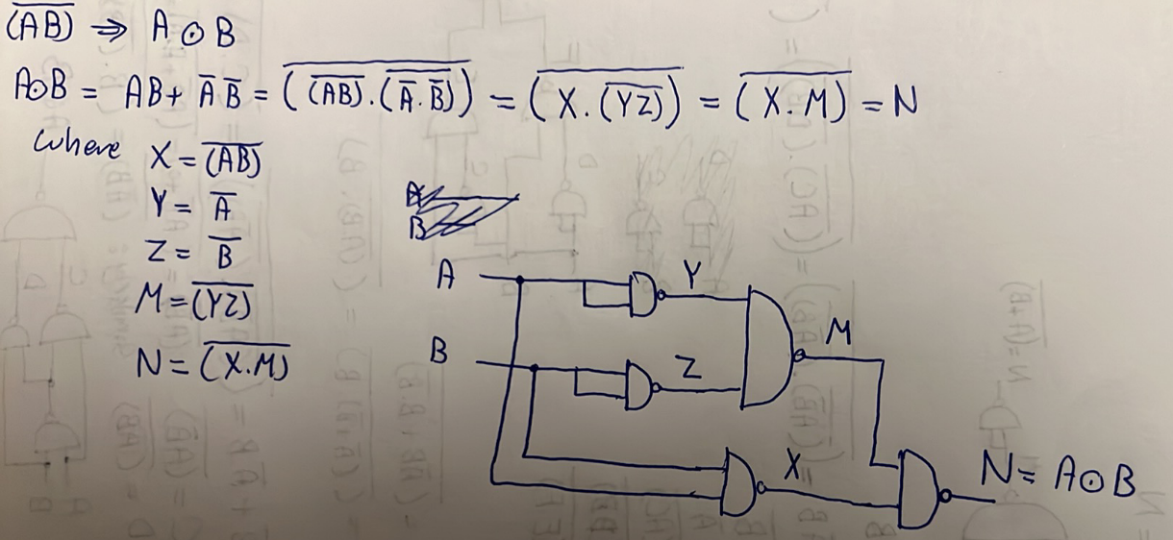
Another solution: invert the second solution of the previous XOR.

Using NOR

NOR to AND
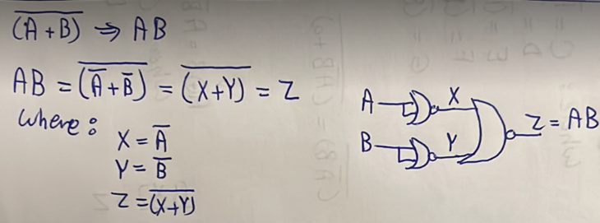

NOR to OR
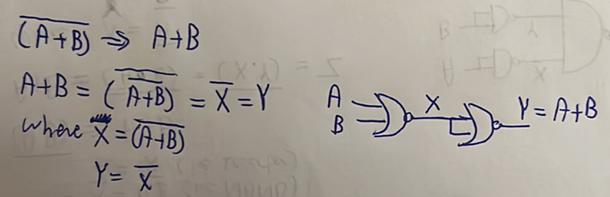

NOR to NAND
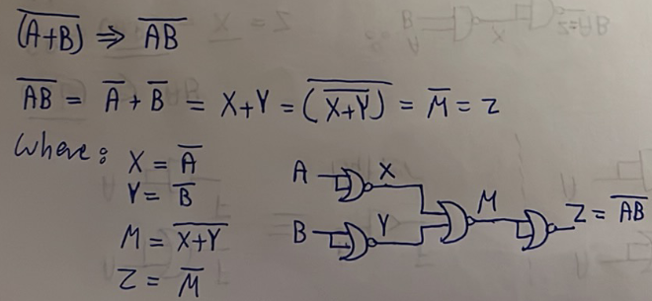

NOR to XOR
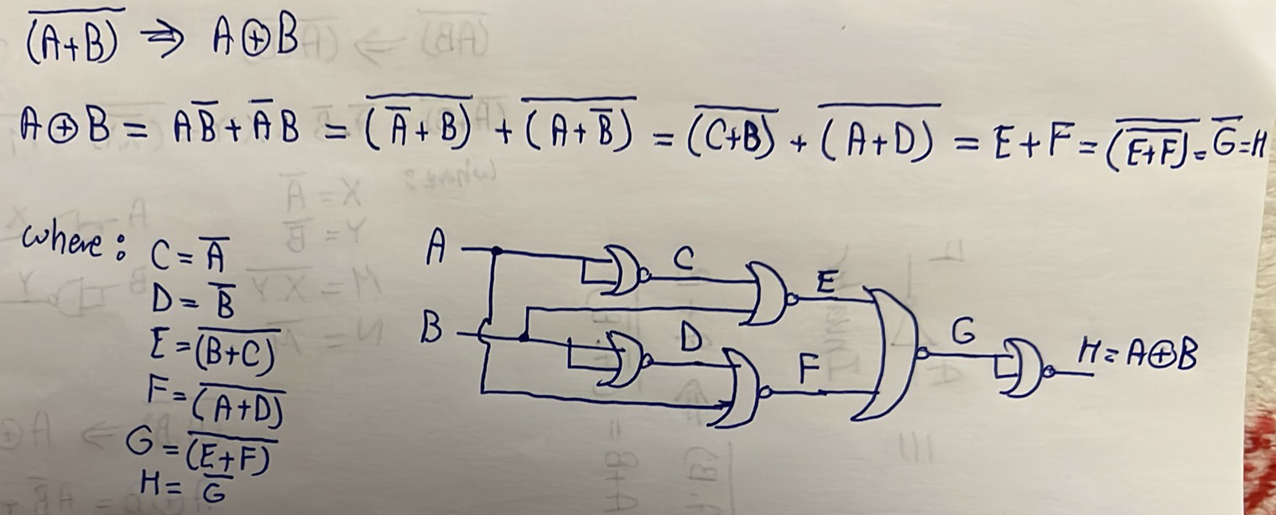
Another better solution (special for XOR gate, mesh sahl yegy 3la balak):
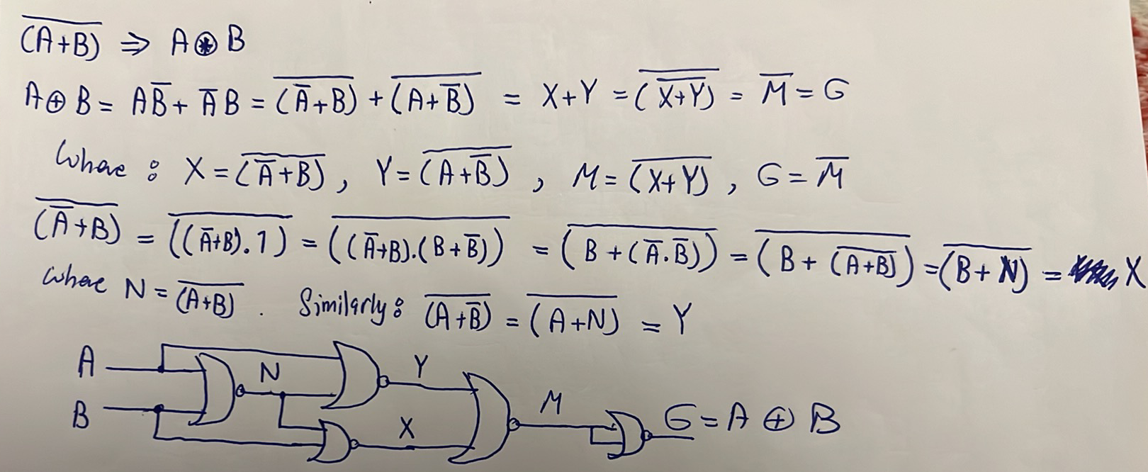

NOR to XNOR
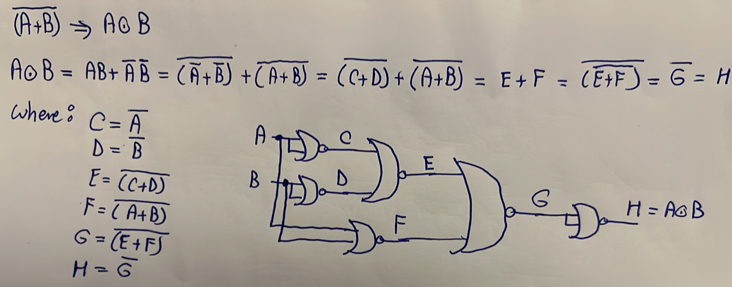
Another much much better solution: invert the second solution of the previous XOR by removing the last NOR gate!
Fa men hena ne2dar netla3 be conclusion kwayes awy w howa enena dayman hanesta5dem el trivial steps of solution 3ady 5ales, ma 3ada ma3 el XOR wel XNOR. Tab hane3mel eh? kol el me7tag te7fazo howa el steps bta3t NAND $→$ XOR w NOR $→$ XOR. Tab wel XNOR? hayeb2o 3obara 3an el inversion bta3 el XOR, fa fel NAND$→$XOR b3d ma tetala3 el gate just 7ot inverter, w fel NOR $→$ XOR b3d ma tetala3 el gate just sheel el inverter el fel a5er. Thus, hate7faz:
1. Normal steps for all conversions.
2. XOR steps of both NAND and NOR.
3. XNOR is just the inversion of XOR.
Using MUXs

$4×1$MUX Using $2×1$ MUXs
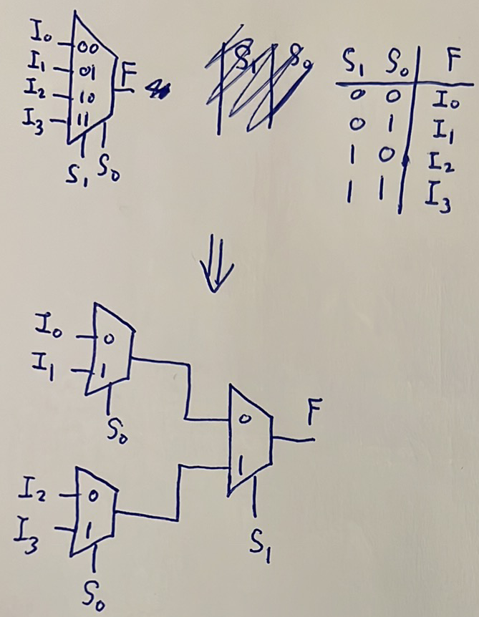

$16×1$MUX Using $4×1$ MUXs
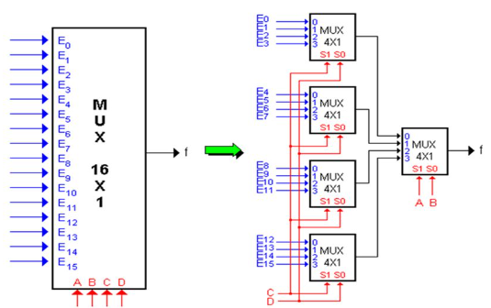

Any Gate Using MUXs
- Any 2-input, 3-input, or 4-input gate can be implemented using a 2x1, 4x1, or 16x1 MUX respectively by simply applying the inputs of this gate to the selection lines of the MUX, and writing the truth table of this gate at the inputs of the MUX. Then, if it is required to use 4x1 only or 2x1 only, just use the previous conversions.

Flip Flops Conversions
Steps:
1. Write the characteristic table of the target flip flop (i.e. table containing $Q_{n}$ + inputs of the target flip flop + $Q_{n+1}$).
2. Deduce equations for the inputs of the available flip flop from $Q_{n}$ and $Q_{n+1}$.
Example:
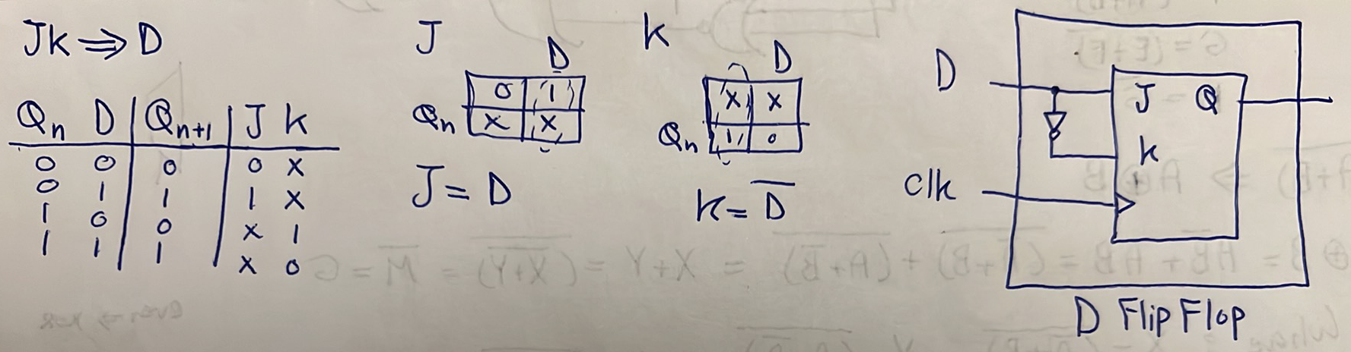
Other conversions here.

